

**AMEIRCAN INTERNATIONAL UNIVERSITY-BANGLADESH (AIUB)**

**FACULTY OF ENGINEERING**

**SOFTWARE ENGINEERING[D]**

**2022-2023 Spring**

**Project Report**

**Title:** Online Veterinary Service

**Supervised by**

Dr.S.M. Hasan Mahmud

Associate Professor

Department of Computer Engineering

**GROUP - 02**

|  |  |  |  |
| --- | --- | --- | --- |
| **Serial** | **Name** | **ID** | **Department** |
| **Submitted by:** | |  |  |
| **1.** | Sadia Islam Trisha | 20-43664-2 | CSE |
| **Team members:** | |  |  |
| **2.** | Khandaker Aznan Alam Seam | 20-44011-2 | CSE |
| **3.** | Sk Ashik-E-Ahmed | 21-44967-2 | CSE |
| **4.** | Fahad Rabbani | 19-41612-3 | CSE |

**Date of submission:** 06 May 2023

LAB 6

(BUG REPORT)

**Home page:**

|  |  |
| --- | --- |
| Project Name: Online Veterinary Service | Test Designed by: Andrew |
| Test Case ID: #201 | Test Designed date: |
| Test Priority (Low, Medium, High): Medium | Test Executed by: Trisha |
| Module Name: Home page | Test Execution date: |
| Test Title: verify GPS navigation for nearby hospital | |
| Description: Test geo location performance | |
| Precondition (If any): The user must be sing up. | |

|  |  |  |  |  |
| --- | --- | --- | --- | --- |
| Test steps | Test Data | Expected Results | Actual Results | Status (Pass/Fail) |
| 1. Go to the application 2. Enter username 3. Enter password 4. Click search | Username:  99999999999  Password: 321 | The user should log in to the application. | As expected,. | Pass |

|  |
| --- |
| Post Condition: The user is validated with database and successfully login to account. |

**LOGIN:**

|  |  |
| --- | --- |
| Project Name: Online Veterinary Service | Test Designed by: Andrew |
| Test Case ID: #201 | Test Designed date: |
| Test Priority (Low, Medium, High): Medium | Test Executed by: Trisha |
| Module Name: Login Session | Test Execution date: |
| Test Title: verify login | |
| Description: Test login criteria | |
| Precondition: The user must be validated by his or her credentials | |

|  |  |  |  |  |
| --- | --- | --- | --- | --- |
| Test steps | Test Data | Expected Results | Actual Results | Status (Pass/Fail) |
| 1. Go to the application 2. Enter username 3. Enter password 4. Click search | Username:  99999999999  Password: 321 | The user should log in to the application. | As expected. | Pass |

|  |
| --- |
| Post Condition: The user is validated with database and successfully login to account. The account session details are logged in the database. |

**DETECTION:**

|  |  |
| --- | --- |
| Project Name: Online Veterinary Service | Test Designed by: Andrew |
| Test Case ID: #203 | Test Designed date: |
| Test Priority (Low, Medium, High): High | Test Executed by: Trisha |
| Module Name: Detection | Test Execution date: |
| Test Title: First Aid detection | |
| Description: Test the AI for the detection | |
| Precondition (If any): Fulfill the credentials to help on detecting the situation | |

|  |  |  |  |  |
| --- | --- | --- | --- | --- |
| Test steps | Test Data | Expected Results | Actual Results | Status (Pass/Fail) |
| 1. Go to the application 2. Enter the type of the animal 3. Enter the category of the situation 4. Click suggest | Username:  99999999999  Password: 321 | The user should log in to the application. | As expected. | Pass |

|  |
| --- |
| Post Condition: The user is validated with database and successfully login to account. The account session details are logged in the database. |

Lab No: 7

Effort Estimation

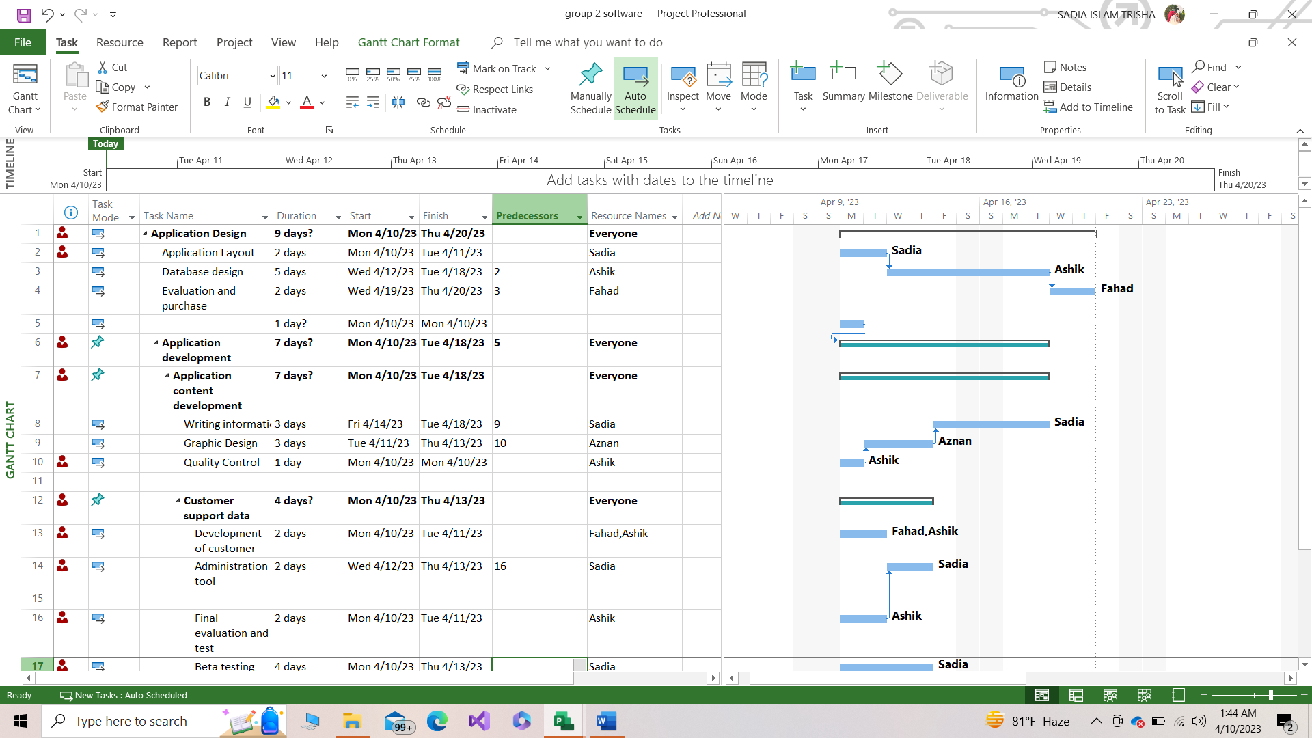

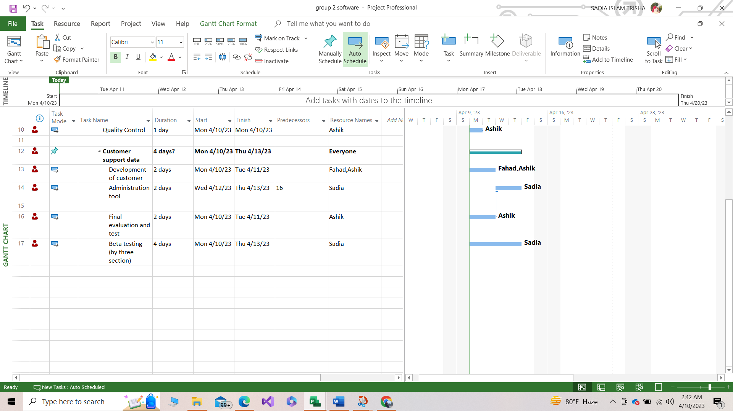

Lab No:8

**Resource Allocation**

**Resource overview**

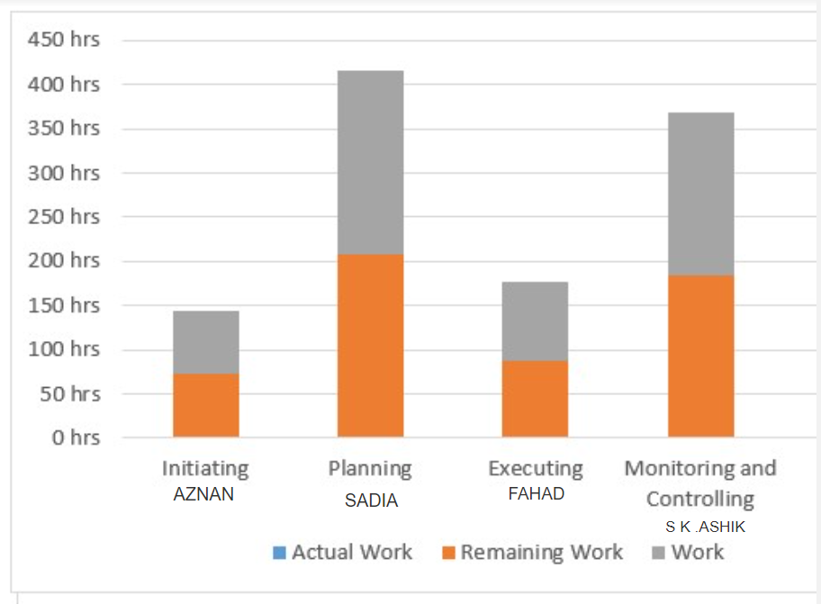

RESOURCE STATUS

Remaining work for all work resources.

|  |  |  |  |
| --- | --- | --- | --- |
| NAME | START | FINISH | REMAINING WORK |
| SADIA | Mon 04/10/23 | Tue 5/10/23 | 215 hrs |
| S.K ASHIK | Sun 04/09/23 | Mon 04/10/23 | 100 hrs |
| AZNAN | Mon 04/10/23 | Thu 04/13/23 | 24 hrs |
| FAHAD | Thu 04/13/23 | Sat 04/15/23 | 24 hrs |

Work completed with 100% teams’ participation.

Lab No:9

**Risk Analysis**

